**Register and Configure an App in Google:**

1. **Login to Google**
2. **Create a New Google App in Google Cloud Platform Set Your App Details**
3. **Create an Oauth Credentials**
4. **Provide necessary details in the app**
5. **Setup redirect URL in the app**
6. **Note down the client-id and client secret of the app**

**Detailed Steps** :

Before accessing developer account, login in to your Google account.

1. [Login to Google](https://developers.facebook.com/docs/apps/register/#login).
2. Access Google Cloud Platform (console.cloud.google.com)
3. Create a project in the console

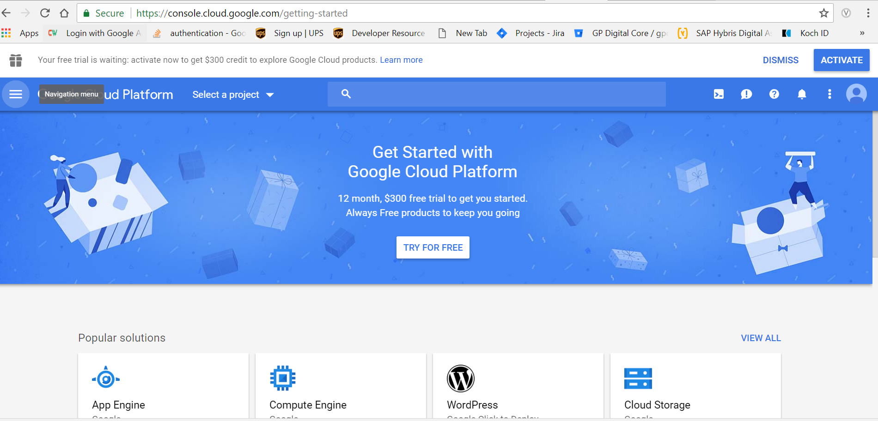

1. Click on new project

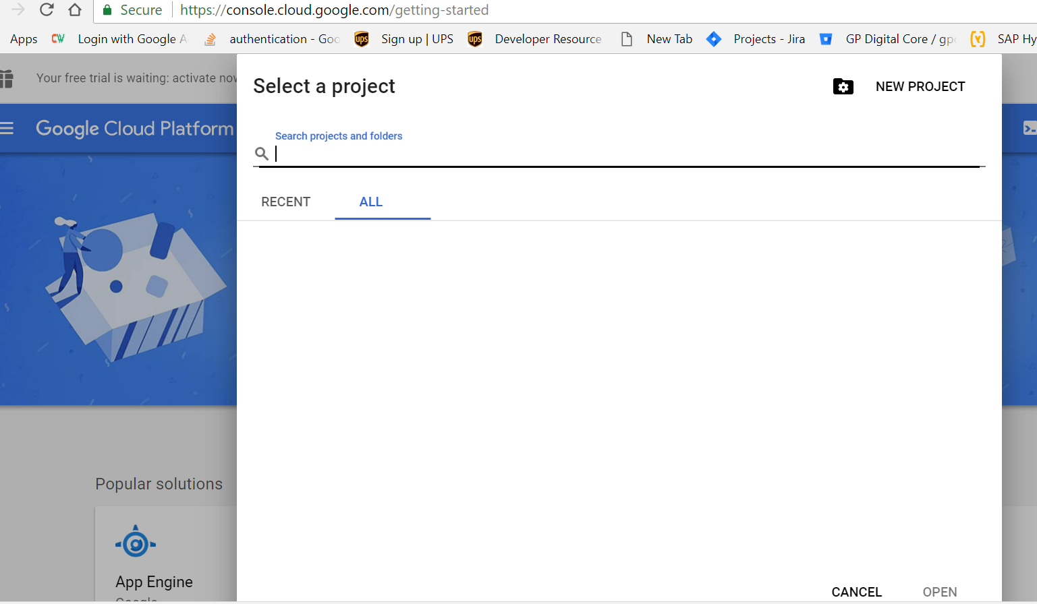

1. Go to API & Services 🡪 Credentials

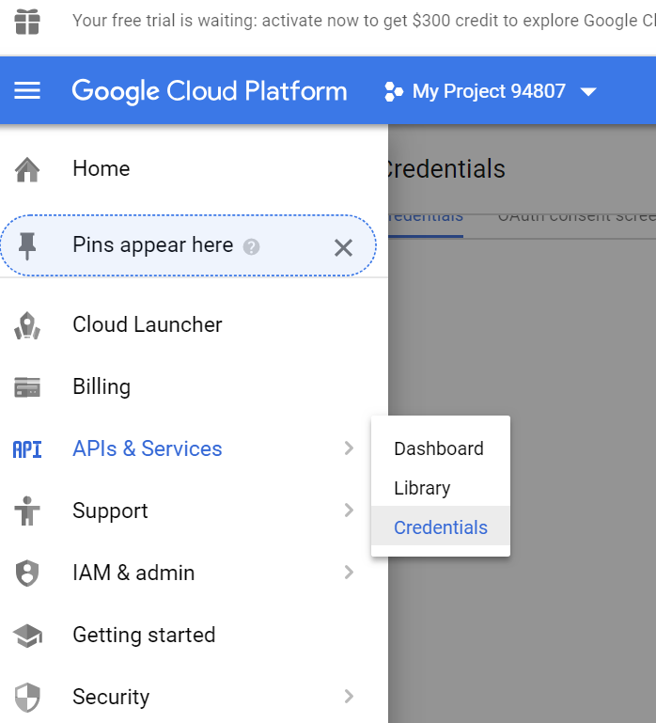

1. Click on Create Credentials and choose Oauth Client option (from the dropdown that appears)

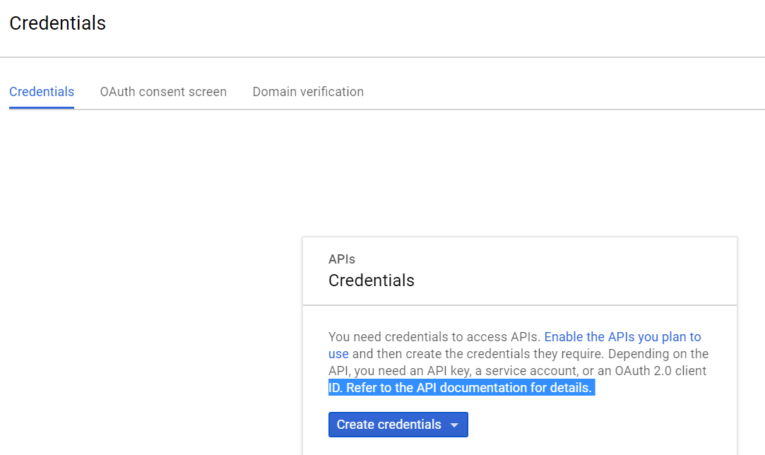

1. Provide necessary details

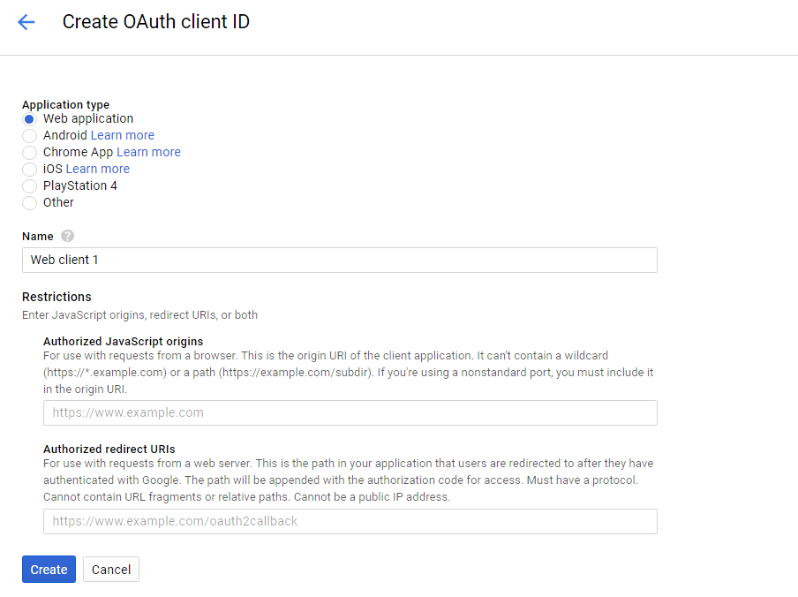

1. You can get the generated Client-id and Client secret. Store it in a secure directory.

